Real-Time Emotion Detection Using CNN and OpenCV
Submitted by: Kinza Rani

1. Introduction
The project 'Real-Time Emotion Detection Using CNN and OpenCV' aims to develop a system capable of detecting human emotions in real-time using a webcam. The model classifies facial expressions into seven categories: Angry, Disgust, Fear, Happy, Neutral, Sad, and Surprise. This project integrates computer vision with deep learning, making it useful for applications like human-computer interaction, online education, and emotion-aware systems.

2. Dataset Description
The dataset used consists of labeled facial expression images distributed across seven emotion classes. The data was preprocessed and split into training, validation, and testing sets as follows:
• Training Samples: 22,968
• Validation Samples: 5,741
• Test Samples: 7,178
• Emotion Classes: Angry, Disgust, Fear, Happy, Neutral, Sad, Surprise
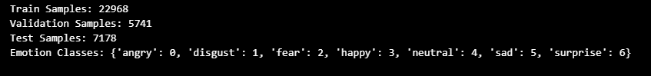

3. Methodology
The process of emotion detection involved several phases including data preprocessing, model training, real-time face detection, and emotion classification.

3.1 Data Preprocessing
Images were converted to grayscale, resized to 48x48 pixels, and normalized. This ensured consistent input size for the CNN model and reduced computational complexity.

3.2 Model Training
A Convolutional Neural Network (CNN) was trained using TensorFlow/Keras. The model was saved using ModelCheckpoint, ensuring that the best version (based on validation accuracy) was stored. After training for 30 epochs, the model achieved a validation accuracy of approximately 51.5% and a test accuracy of 53.7%.
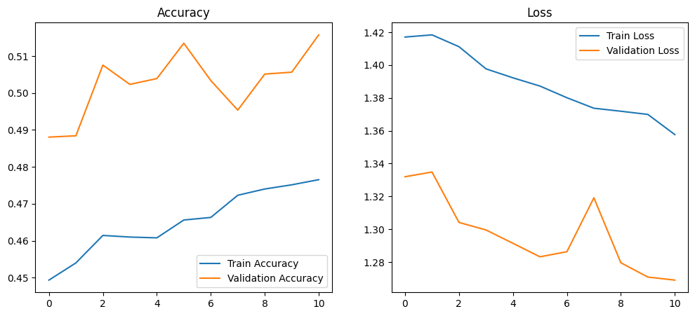

3.3 Model Evaluation
The trained model was evaluated using a confusion matrix and classification report to analyze per-emotion performance. The highest accuracy was observed for the 'Happy' and 'Surprise' categories.
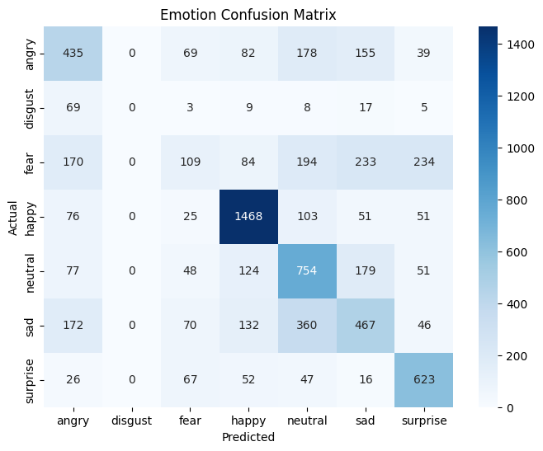

4. Real-Time Emotion Detection
The trained CNN model was integrated with OpenCV to perform real-time emotion detection. The system uses Haar Cascade for face detection, crops the detected region, and passes it through the model for prediction. The predicted emotion label is displayed directly on the webcam feed.
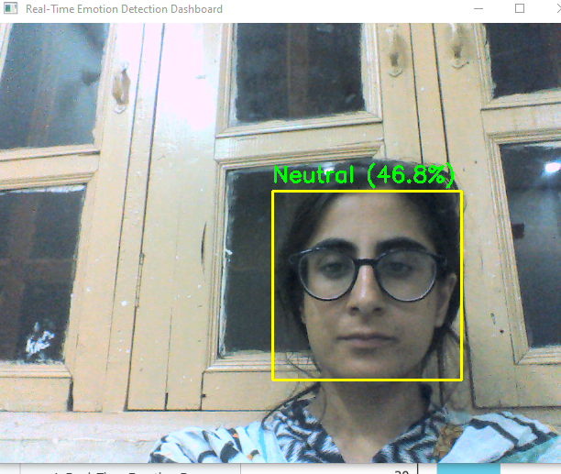

5. Optimization for Real-Time Performance
To ensure smooth and real-time emotion detection, optimizations were made such as resizing the frame, reducing model complexity, and using efficient OpenCV operations. This significantly reduced latency between frame capture and prediction.

6. Extended Functionality
An emotion analytics dashboard was implemented to record emotion frequencies during live sessions. The data can be used for further analysis or visualization of emotion trends over time.
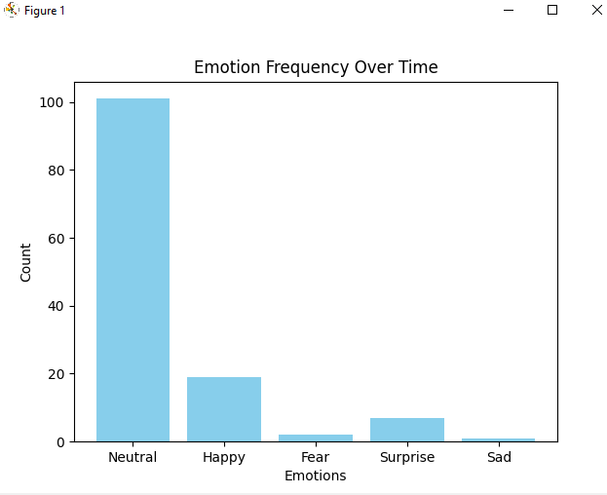

7. Results and Conclusion
The CNN-based model successfully detected facial emotions in real-time with over 53% accuracy on the test dataset. It demonstrated strong performance for expressions like 'Happy' and 'Surprise'. Further improvements could be achieved by increasing dataset size, applying data augmentation, and using deeper architectures like ResNet or VGG.

8. Future Work
In future enhancements, the model could be integrated into mobile or web-based applications using frameworks like Streamlit or Flask. Additional features such as emotion trend tracking and voice feedback could make the system more interactive.

